Lesson Plan Template

Location of Course: _____KCFR______ Date: ____________

Instructor: _______KCFR___________ Length of Class: _1 hour

Target Audience: __Suppression Personnel________________

Lesson Title: _ECO (Engine Co. Ops): The deuce and a half

Motivation:
Use of the 2 ½ inch handline seems to have been abandoned in recent history; this may be the result of staffing cuts or the lack of appropriate training. In either case, this is an extremely effective tool that should not be ignored. All of the techniques demonstrated in this drill can be performed with an engine company that is minimally staffed (i.e. three personnel).

Objectives:
The firefighter will demonstrate a general understanding of the construction, operation, and utilization of fog and solid stream nozzles and, by participation and observation, a knowledge of the various nozzles, hose layouts, appliances, and procedures involved in applying water at a structural fire.

Material:
Minimum
1-Engine
1-Each type of nozzle (Sabre Jet, Automatic, Smooth Bore)
300’ 2 ½” Hose (100’ per nozzle)
Full PPE

Overview: This training has been designed to be a basic overview of the use of a 2 ½” hoseline during engine company operations. For this training you will have one engine supplying the three lateral lines (each 100’ long). One type of nozzle will be on each lateral. Flow water out of each lateral, at the appropriate pressure, at the nozzle tip (Sabre Jet-75 psi, Automatic-100 psi, and Smooth Bore-50 psi) simultaneously. Permitting there are enough FF’s for each station. All techniques shall be demonstrated on each of the following laterals. The techniques are as follows: Single FF/hose pinned with knee, single FF/hose locked between arm and leg, and two FF’s/back-to-back.

Clock Time: | Main Points: | Methods, Media:
25 min | Pretest  Grade test as group  Review ADULTS acronym  - Situations where a large line is  needed:  Utilize the acronym ADULTS  A – Advanced fire on arrival  D – Defensive  U – Undetermined location/extent of the  fire  L – Large/uncompartmented areas  T – Tons of water needed  S – Standpipe Operations | Classroom use test provided
10 min | - Demonstrate the following techniques:  - Single firefighter/hose pinned with knee:  The rear leg must be perpendicular to  the handline, so that the knee stays in  position and doesn’t roll off. The nozzle  reaction is driven into the ground.  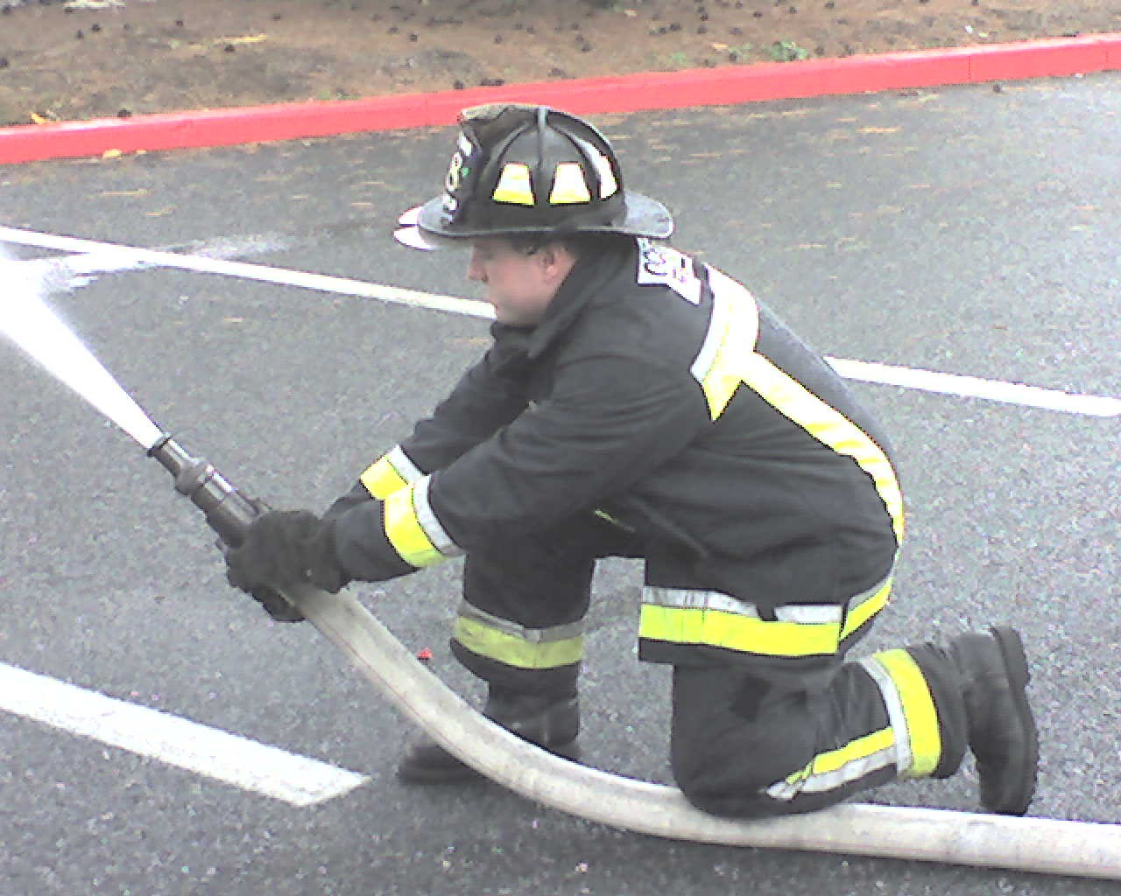 | Hands On
10 Min | - Single firefighter/hose locked between  arm and leg:  The line should be locked between the upper  arm and the torso (up in the armpit) and the  right arm should be locked against the inside of  the thigh. Notice the back leg is up and the  front leg is down.  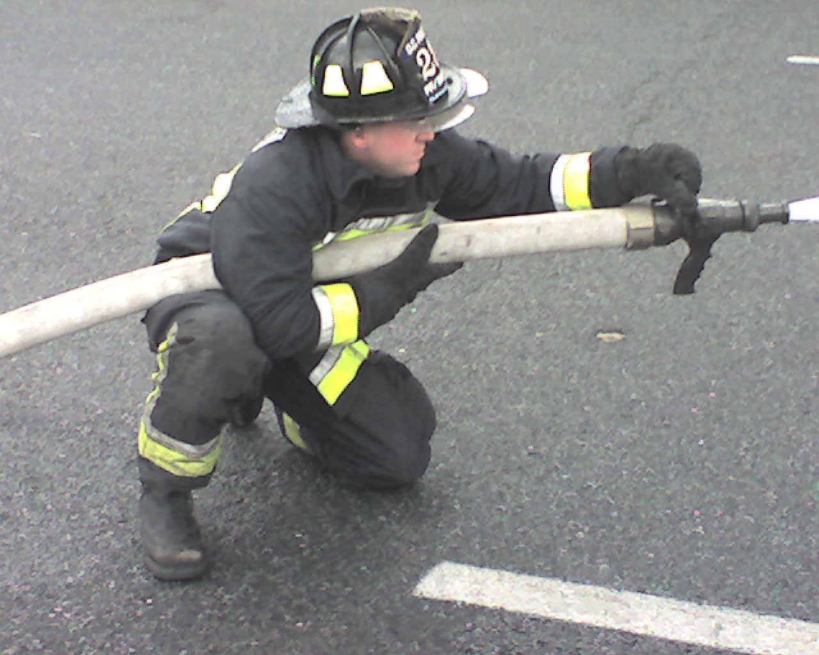 | Hands On
10 Min | - Two firefighters/back-to-back  This can be done with airpacks on.  The backup person should be doing the bulk  of the work; notice how the backup person  is using their legs and their body weight to  help control the line. This makes the work  much easier.  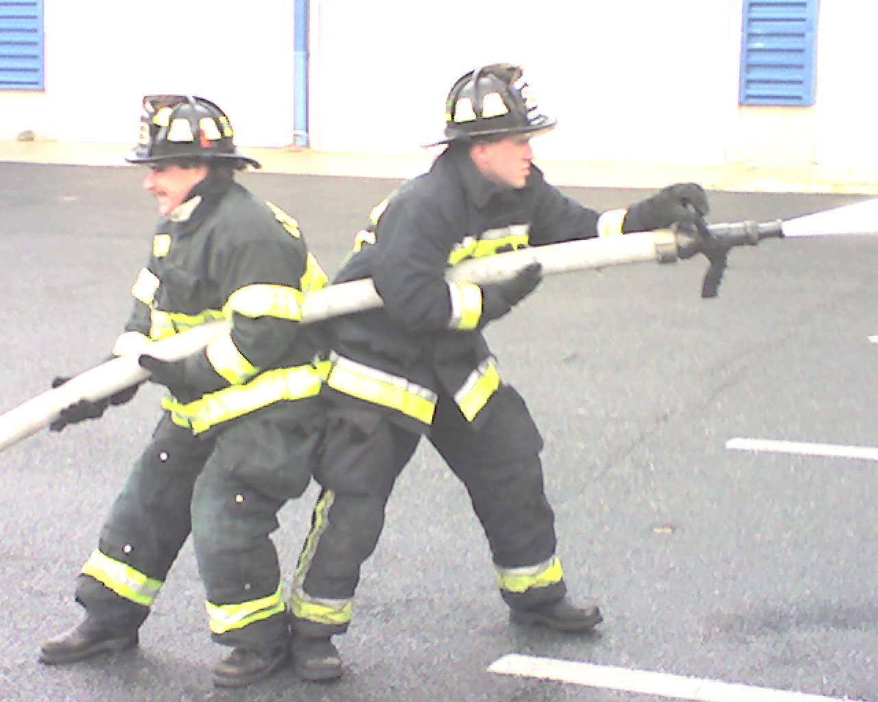 | Hands On
 | Have all participants demonstrate above techniques. Ensure that back-up personnel are in position and prepared to intervene/provide assistance

